**ASSIGNMENT 1**

**Submitted by: Sanchita Nagulwar**

**Git version:**

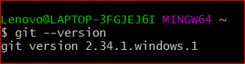

1. **Create a directory ‘project_dir’ & cd to ‘project_dir’.**

**Command used:** mkdir project_dir,

cd project_dir

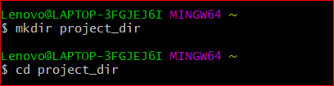

1. **Initialize git version database. (git init)**

**Command used**: git init

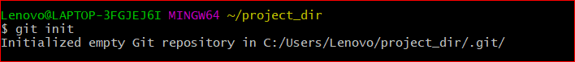

1. **Create a new file index.html.**

**Command used:** touch index.html

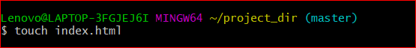

1. **Check the git status. You should find index.html as untracked file.**

**Command used:** git status

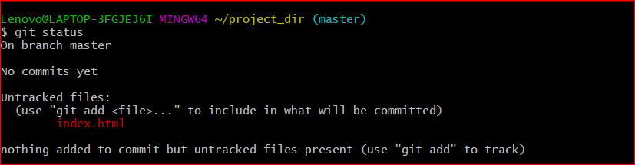

1. **Stage the index.html file.**

**Command used:** git add index.html



1. **Commit index.html**

**Command used:** git commit -m “committing html file”

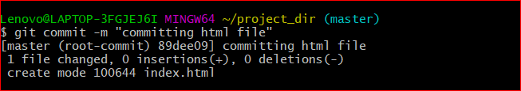

1. **Make few changes in index.html & create a new file info.txt file.**

**Command used to create a new file info.txt:** touch info.txt

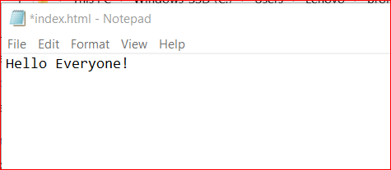

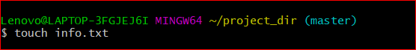

1. **Check git status. You should find index.html & info.txt as untracked files.**

**Command used:** git status

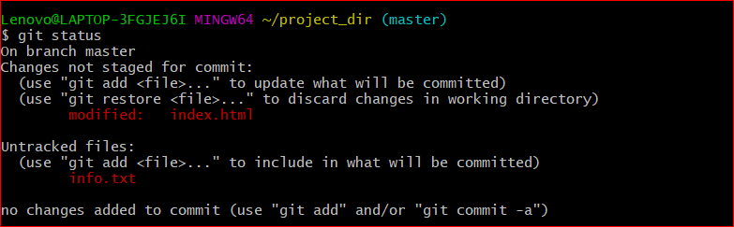

1. **Configure GIT to ignore all txt files.**

**Command used:** touch .gitignore

In .gitignore file write **\*.txt** to ignore all txt files

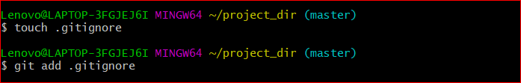

1. **Again check the git status. You should find only index.html as untracked file.**

**Command used:** git status

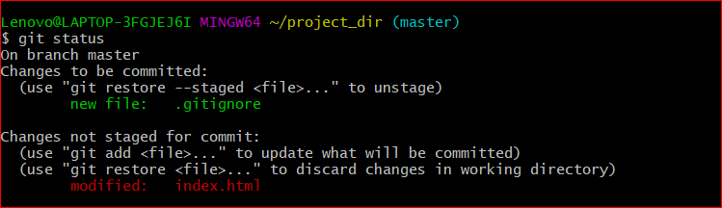

1. **State & commit index.html**

**Command used: for state:** git add index.html

**for commit:** git commit -m “modified index.html”

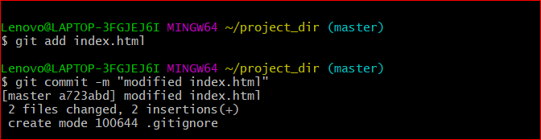

1. **Log all your comments so far.**

**Command used:** git log

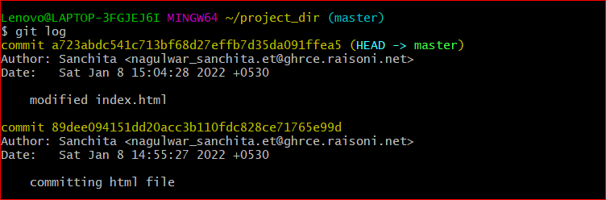

1. **Make some changes in index.html.**

**Command used to see the changes:** git diff index.html

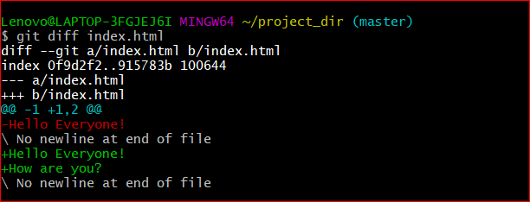

1. **Revert the change made in the previous step using git command.**

**Command used:** git checkout index.html

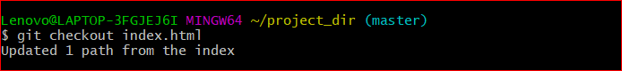

1. **Again change index.html.**

**Command used:** git diff index.html

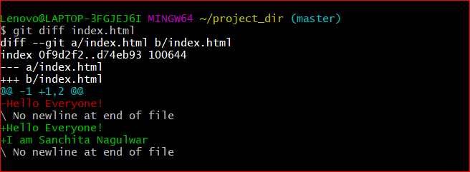

1. **Stage index.html**

**Command used:** git add index.html

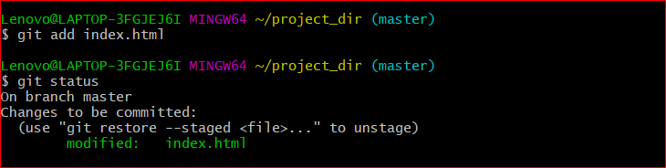

1. **Revert back the last stage.**

**Command used:** git checkout -f

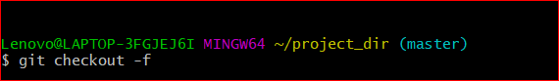

1. **Rename ‘add’ command to ‘my-add’.**

**Command used:** git config --global alias.my-add add



1. **Using my_add command Stage index.html again & commit the changes.**

**Command used:** git my-add index.html

Git commit **-**m “Added a line”



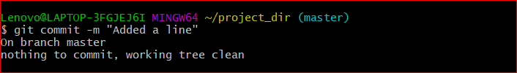

1. **Revert the last commit.**

**Command used:** git revert HEAD

